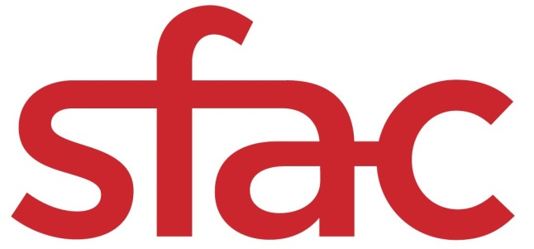
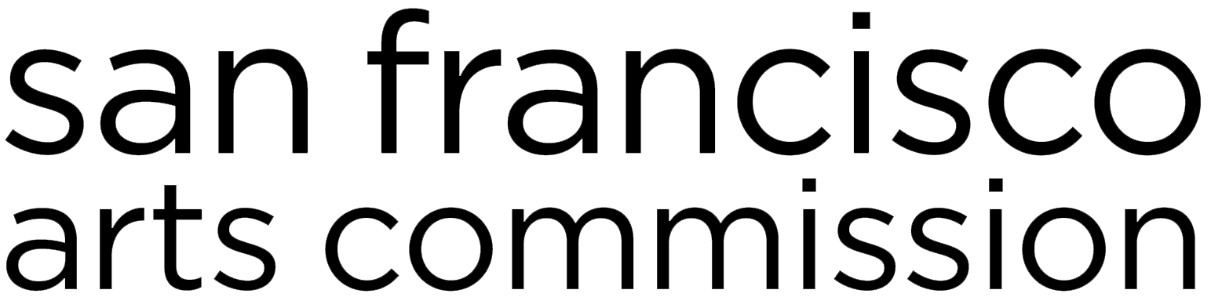

Native American Arts and Cultural Traditions Special Grants (NAACT-SPX)| Grant Guidelines & Application
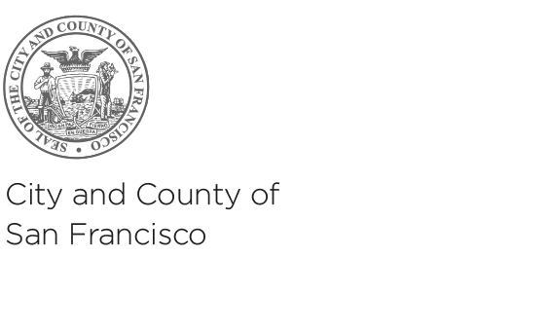
FOR PROJECTS TAKING PLACE JULY 2019 — JUNE 2020.

APPLICATION DEADLINE: Monday, April 8, 2019 at 12 p.m. noon PST
(submission by email to barbara.mumby@sfgov.org)

For any questions about Special Project Grants, contact Director of Community Investments, Barbara Mumby at barbara.mumby@sfgov.org or 415-252-2215.

San Francisco Arts Commission  Tom DeCaigny  Director of Cultural Affairs  401 Van Ness Avenue, Ste. 325  San Francisco, CA 94102  tel 415-252-2590  fax 415-252-2595  sfartscommission.org  facebook.com/sfartscommission  twitter.com/SFAC | *A translation of this grant application is available upon request; however, only applications in English will be accepted. For more information, please contact 311.  Una traducción de esta solicitud de aplicación está disponible a petición; sin embargo, solamente se aceptarán solicitudes en inglés. Favor comunicarse con Kate Patterson-Murphy al 415-252-2229 ó kate.patterson@sfgov.org para una traducción al español.  本資助申請表的翻譯版本將應請求而提供；但僅受理英文版本的申請表。 查詢詳情，請聯絡311。  Ang pagsasalin sa Tagalog ng aplikasyon para sa pagkalooban na ito ay makukuha kung hihingilin. Ngunit ang aplikasyon sa Ingles lamang ang aming tatanggapin. Para sa tulong, maaring i-contact si Cece Carpio, 415-252-2217 o cece.carpio@sfgov.org.

About Native American Arts and Cultural Traditions Special Grants (NAACT-SPX)
Important Dates

Applications Due April 8, 2019, 12 NOON PT

Application Review April 10, 2019

Funding Recommendations April 23, 2019

Commission Approval May 6, 2019

Grant Period June 1, 2019-June 30, 2020

About NAACT-SPX
The Native American Arts and Cultural Traditions Special Grants (NAACT-SPX) consist of one-time grants to address emerging needs within the arts ecosystem of San Francisco that support and/or highlight the Native American community. Projects cover a wide range or arts activities related to arts access. For questions about this grant category, please contact Director of Community Investments, Barbara Mumby at barbara.mumby@sfgov.org or 415-252-2215.

Eligible Request Amount
This Special Project Grant RFP is for projects up to $10,000.

How to Apply
Applications must be received by email no later than 12pm (noon PST) on Monday, April 8, 2019. In fairness to others, we cannot accept late or incomplete applications. An application may be deemed incomplete and ineligible if the applicant does not provide the complete set of information in the appropriate format by the deadline. No deadline extensions will be granted.

DEADLINE TO APPLY: 12 p.m. noon PT on Friday, April 8, 2019

Project Descriptions
- Project support for individual artists that are deeply rooted in the Native American Community: Support up to $10,000 for Individual Artists living and working in San Francisco for specific projects that stimulate the creation and presentation of creative works of art presented throughout the city’s neighborhoods. Artists may request funding for the full artistic process, or one phase of a larger creative arc, as long as project scope is appropriately scaled to funding request and project goals. The artist should be focused on realizing creative or aesthetic ideas, rather than on documentation, archiving, or journalism. Although collaboration is acceptable, the individual artist is the grantee. Applicants should be able to demonstrate their deeply rooted connection to the Native American community.

This grant will only consider proposals in literary arts, media arts, and visual arts.

- Project support for arts organizations deeply rooted in the Native American Community: Support up to $10,000 for non-profit arts organizations located in San Francisco to highlight the cultural traditions of the Native American community. Specifically, the proposed project should provide an opportunity to engage and celebrate the resurgence and resilience of Indigenous peoples in traditional practices with an emphasis on California Native culture.

Who Can Apply

Eligibility

If the applicant is an individual:
- The applicant must be a continuous resident of San Francisco since October 2016. The purpose of this category is to support San Francisco-based individual artists in the production and dissemination of works of art in San Francisco. Applicants must submit paperwork demonstrating San Francisco residency with their application.
- The artist must be at least 18 years old.
- To be eligible for this grant, the artist must have held two publicly accessible activities or events in San Francisco that span from October 2016 to the grant deadline.
- Artists in any phase of their artistic career can apply including emerging, midcareer, and established artists.
- The artist cannot be enrolled as a full-time student at the time of the application or during the grant period.
If the applicant is an organization:

- The applicant organization must be tax-exempt under Internal Revenue Code Section 501(c)(3).
- The organization must be based in San Francisco.

- The organization’s mission statement must be clearly focused on increasing the financial resilience and sustainability of community-based nonprofits.

All applicants:

- Applicants cannot be part of another City agency or department.

- Applicants must not be in default on any grants or loans from: (1) SFAC, (2) other City departments (including, without limitation, the Department of Children, Youth, and their Families; Office of Economic and Workforce Development; Mayor’s Office of Housing and Community Development; and Grants For The Arts), (3) Northern California Grantmakers Arts Loan Fund; (4) Northern California Community Loan Fund, (5) Community Arts Stabilization Trust; or (6) the Center for Cultural Innovation. This default clause was expanded due to the fact that SFAC has a fiduciary relationship with these particular organizations, through either shared City resources or other pooled philanthropic funds.
- The proposed project must take place in San Francisco between June 1, 2019 and June 30, 2020.
- The applicant must be willing and able to meet the requirements associated with receiving funds from the City and County of San Francisco. In order to receive a grant from the San Francisco Arts Commission, you must become a registered, compliant supplier (formerly called a vendor) and meet the City of San Francisco's insurance and business tax requirements. For more information about vendor requirements, visit: http://sfgov.org/oca/qualify-do-business. Please note if you are not already a City supplier, you will only be required to register if you are awarded a grant. Insurance and business tax requirements will be explained and made available upon approval of grant awards.

Restrictions
- A proposed project cannot receive simultaneous funds from multiple SFAC funding sources; this includes collaborators applying to work on different components of the same project and applying separately.
- Applicants cannot submit more than one application.

- Applicants cannot receive funding for two consecutive grant cycles in the Individual Artist Commission category. All of our grantees are required to sit out for one year after each grant cycle. In addition, they are required to close out a grant before reapplying.
- The awarding of funds does not imply that the Arts Commission or any other City agency will produce, exhibit, promote or present the art created. It is the responsibility of the applicant to secure a venue, appropriate insurance and any required permits for public presentations.
- Grant funds may not pay for:
- Public presentation activities outside of San Francisco;
- Projects for which the main intent is curation, archiving, or journalism.

Project Requirements
- Public Presentation Requirement: A public presentation of the commissioned work is required. The broadcast of a radio documentary or podcast or release of a web-based project does not fulfill this requirement on its own but rather requires a physical gathering of the audience. The public presentation can be of a work-in-progress or of the final, polished piece. The presentation must take place in San Francisco within the grant period. Venues can be formal or informal.
- Fiscal Sponsorship: If the applicant would like to work with a fiscal sponsor, a fiscal sponsorship letter of agreement, signed by the applicant and staff of the fiscal sponsor, must be submitted with the application.
- Collaborative Projects: A group of artists may come together to create a specific project, but the lead artist will be the main contact and applicant for the grant application.

Grantee Requirements
- City Permits and Permissions: If the proposal includes components that require City permits or approval such as publicly installed art, street closures, sound amplification in public space, or murals, the artist will be solely responsible for securing the necessary permits, permissions, insurance, and approvals. This planning should be reflected in your project timeline.
- Insurance Requirements:
General Liability: Awarded grantees will need to submit a certificate of General Liability Insurance and an Endorsement Page with first invoice. General liability insurance cannot be waived. This requirement can met by the following:
  - Purchasing General Liability Insurance as an individual artist or organization.
  - Purchasing Special Event Insurance for any public events associated with the grant project.
  - Obtaining a General Liability Insurance certificate from their host venue, which adds the grantee and event to their policy by endorsement and lists the San Francisco Arts Commission as additionally insured.
Workers Comp Insurance: Workers Comp insurance is required for an organization that has employees. If you do not have employees, the San Francisco Arts Commission will provide a waiver for this requirement.
NEW: Waiver of Subrogation addendum is required for organizations to do work on ANY City-owned property.

Auto Insurance: Auto Insurance is required if the awarded grantee will use a vehicle for the purposes of the grant. The San Francisco Arts Commission will provide a waiver for this requirement.

Abuse and Molestation Insurance: Proof of Abuse & Molestation coverage in addition to General Liability coverage is required for working with vulnerable populations (minors, disabled people, or elderly people).
Art Installation: Please note that any art installed with these grant funds on property owned by the City and County of San Francisco or on private property, must be reviewed and approved by the San Francisco Arts Commission starting with the Visual Arts Committee of the Commission. This applies to murals, public sculpture, and similar projects. It will be the responsibility of the grantee to build this process into their grant plan and timeline. Please contact the following Public Art Program staff if you have questions: Alyssa Torres at alyssa.torres@sfgov.org for murals.
Panel Evaluation and Scoring Criteria
Grants Panelists
Special Project grant applications are evaluated in a closed panel review process by SFAC staff and partners. Grant review panelists will have experience that aligns with the purpose of the specific grant category.

Application Review
Grantees will be selected by a staff review process comprised of representatives from the San Francisco Arts Commission and may include other City department staff or funding partners. Panelists will review applications and make funding recommendations. Priority will be given to applicants who successfully meet the criteria within each funding category.

Funding Recommendations
Based on an evaluation of the proposals, panel scores create a ranking for funding recommendations. Staff may also take into consideration discipline when determining how deep into the ranking recommended funding will go. Applicants that do not score above 75 percent of the allotted points will not be eligible for funding.

Panel Notes
Panelists may take notes during their review. You may contact sfac.grants@sfgov.org to obtain panel comments.

Funding Approval
Panel recommendations are subject to the approval of the Arts Commission. Typically, recommendations are first reviewed by the Community Investments Program Committee, then by the full Commission. Meetings of the Commission are public. The agenda will be available on the Arts Commission website at sfartscommission.org 72 hours in advance of the meeting.

Grant Awards
Grant award notifications will be emailed following Commission approval and include instructions about contracting procedures.

Scoring Criteria
Panelists will be instructed to use the following scoring criteria that correspond with the noted application questions. Close review of this grid may help you focus your application responses.

CATEGORY | POINTS | SCORING CRITERIA | APPLICATION QUESTIONS
Alignment with SFAC Cultural Equity Goals  (20 points) | 20 | Applicant aligns with SFAC’s goals in equitable grantmaking. | - Describe your relationship to historically marginalized communities.
Quality of Proposed Project  (45 points) | 20 | Project goals and processes are defined and demonstrate originality, clarity, and depth of concepts. | -Describe your proposed project in detail. What is the concept? What are your goals, areas of exploration, and primary methods or techniques?
 | 10 | Applicant demonstrates that the proposed project will impact their development and future opportunities. | - Describe the significance of this project for you at this time. What long term impact will this have on future opportunities?
 | 10 | Applicant demonstrates learning opportunities through the project evaluation. The documentation plan will maximize the impact of the project. | - Describe your evaluation and documentation plans.
 | 5 | Central activities and targeted outputs are provided in a manner that clearly represents the core of the project. | - List up to five key activities and measured deliverables.
Public Benefit (10 points) | 10 | The proposed public presentation is appropriate to the project goals and feasible in its potential to share the work with a defined San Francisco audience. Applicant has identified at least one venue for public presentation. | - Describe the public presentation, target audience and your relationship to them.  -Describe your outreach plan to the identified audience or community.
Ability to Complete the Project  (25 points) | 15 | Applicant’s history shows coherence or evolution, commitment to advancing artistic and/or social ideas, and appropriate preparation to complete the proposed project. | - Describe your artistic history and major areas of inquiry. Indicate prominent themes, issues, or questions explored.  - Describe major activities or achievements in your career/organizational history.  - List of SF-based activities.  - Individual Artist: Submit a resume or CV, maximum of 2 pages.  -Organization: Submit a list of activities, maximum of 2 pages
 | 10 | Work samples demonstrate artistic vision, craftsmanship, and ability to execute the proposed project. | - Provide a maximum of three work samples.

Application
In a separate word document, please answer the following questions and email, along with attachments and work samples to barbara.mumby@sfgov.org no later than 12 noon PST on Monday, April 8, 2019:

COVER PAGE
Include the following information:

Name
Organization Name (if applicable)
Address
Phone Number
Email
Fiscal Sponsorship Information if applicable

NARRATIVE
Answer the following questions in 12pt font (four-page maximum):

Alignment with SFAC Cultural Equity Goals (20 points)

- Describe your relationship to historically marginalized communities.

Quality of Proposed Project (45 points)

- Describe your proposed project in detail. What is the concept? What are your goals, areas of exploration, and primary methods or techniques?
- Describe the significance of this project for you at this time. What long-term impact will this have on future opportunities?
- Describe your evaluation and documentation plans.
- List up to five key activities and measured deliverables.

Public Benefit (10 points)

- Describe the public presentation, target audience and your relationship to them.
- Describe your outreach plan to the identified audience or community.

Ability to Complete the Project (25 points)

- Describe your artistic history and major areas of inquiry. Indicate prominent themes, issues, or questions explored..
- Describe major activities or achievements in your career/organizational history.
- Provide a list of up to two SF-Based activities that span from October 2016 to October 2018.
- If you are an organization: Submit a list of major activities (2 page maximum)
or
If you are an Individual Artist: Submit a resume or CV (2 page maximum)
.

ATTACHMENTS

- A Resume/CV or List or Organization Activities (2 page maximum)
- A maximum of three (3) work samples
- Proof of San Francisco residency (Driver’s license are not acceptable)

