FOR IMMEDIATE RELEASE
Media Contact:
Wendy Norris
T: 415-307-3853 E: wendy@norriscommunications.biz

SAN FRANCISCO STAGES FASHION SHOW FEATURING INDIGENOUS DESIGNERS
December 15 in City Hall’s Rotunda
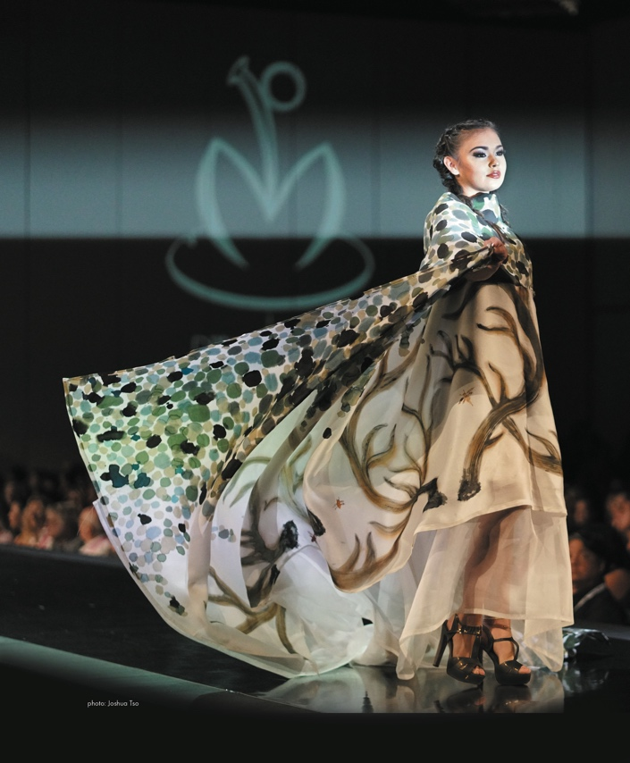 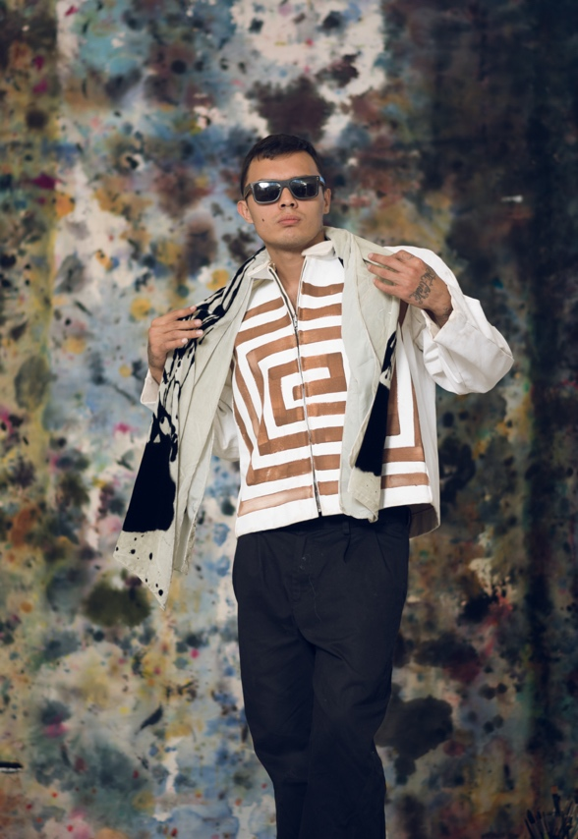
As part of a citywide American Indian Initiative in honor of the 50th Anniversary of the Occupation of Alcatraz, the San Francisco Arts Commission will host a free fashion show featuring acclaimed designers Leah Mata, Patricia Michaels, and Sho Sho Esquiro

SAN FRANCISCO, NOVEMBER 2019 – On Sunday, December 15, 2019 from 4pm – 6pm, acclaimed designers Sho Sho Esquiro (Kaska Dene, Cree) and Project Runway alumna Patricia Michaels (Taos Pueblo) will participate in San Francisco’s first fashion show dedicated to work by Indigenous Peoples. Their models will walk a runway in San Francisco’s iconic City Hall Rotunda. Organized by the San Francisco Arts Commission in partnership with Sewam American Indian Dance, the fashion show is intended to reclaim space for Indigenous Peoples in the public realm and bring awareness to an alarming epidemic of murdered and missing Ingenious Women.
The fashion show is part of a citywide American Indian Initiative titled The Continuous Thread: Celebrating our Interwoven Histories, Identities and Contributions that coincides with the 50th Anniversary of the Occupation of Alcatraz, the one-year anniversary of the City’s first Indigenous People’s Day and the anniversary of the removal of the Early Days sculpture. The Initiative includes over 14 community partners and features exhibitions, a temporary light-art project, public celebrations, and a wide array of free art programs.
According to SFAC Director of Community Investments Barbara Mumby-Huerta (Powhatan, Shawnee, Konkow), “This program was inspired by the incredible work of these designers who are taking the world stage by storm. At the same time, we felt it was important to use the platform to shine a light on the great disparities faced by the Indigenous community, specifically, the fact that Indigenous Women are 84 percent more likely to experience violence in their lifetimes compared to other communities.”

ABOUT THE DESIGNERS
Leah Mata is a member of the yak tityu tityu yak tiłhini (the people of tiłhini) Northern Chumash Tribe, located on the Central California Coast. Leah works as a contemporary artist creating through traditional practices, focused on living forms of regalia and jewelry while building ongoing traditions in California Indian arts. Her work as yak tityu and an artist is grounded in an understanding of the past that is interdependent with the future.
Mata has earned top honors such as the Autry Indian Market 2012 - Best in Diverse Cultural Arts, Heard Museum Fair 2013, 2016 - First Place, 2018 Best of Classification in Personal Attire. Santa Fe Indian Market 2018 Personal Attire- Second Place. In 2011, Leah was awarded the Smithsonian Artist Research Fellowship, and was selected as a Master Artist recipient for Alliance of California Traditional Arts (ACTA) in 2013. Most recently Mata is the 2020 Barbra Dobkin Fellow at the School of Advanced Research. Mata’s education, which includes a B.A. in Anthropology and a M.A. in Cultural Sustainability, has afforded her access to various collections and archives, furthering understanding of the technical and material expertise of yak tityu tityu (The People) and resisting the hindered access for community members whose relatives’ works are held in academic collections.
Unlike other mediums, most of the materials needed to create traditional Northern Chumash material culture are site-specific and can require years of planning to complete each piece. The importance of gathering materials seasonally and with respect for the limits of each environment, even before they can be processed and then used, is a practice she engages in collaboration with homeland and her family. Leah is committed to environmental issues that directly impact the ability to gather materials needed to sustain her traditional arts. Finding ways to assure each generation can sustain these art forms is an integral part of Mata’s process, which allows her the ability to incorporate her artistic practice with her intention as an educator, researcher, and community member.
Patricia Michaels, for over 20 years, has been producing one-of-a-kind haute couture that transcends cultures and defies fashion trends. Growing up in Santa Fe, New Mexico, she was surrounded by beauty—in culture, landscape, and art, all which greatly influenced her design aesthetic. She named her company, PM Waterlily, after her Native name, vowing to keep her traditions alive through the interconnectedness of her fashions. In this respect, Patricia has become a forerunner in the fashion industry for practicing cultural sustainability.
Patricia has gained national recognition for Peabody Essex Museum show, "Native Fashion Now" 2015, and international attention in 2014 after receiving the highly prestigious Arts and Design Award from the Smithsonian National Museum of the American Indian board of directors in New York City. She is the very first recipient of this award, an historic achievement.
After her successful run on the Emmy Award-winning season 11 of “Project Runway” in 2012 where she won the first runner up title, she was asked back to star in “Project Runway All Stars” Season 4. Her “Project Runway” debut was a first for a Native American designer and has brought many new opportunities to showcase her highly sought out fashion and textiles. Other accolades include: the "Taos Citizen of the Year Award"; the "Eugene Crawford Memorial Peace Pipe Award”; a Letter of Recognition of Achievements by the New Mexico State Senator's Office and Senator Tom Udall; and "BEST of the WEST 2013" by Cowboys & Indians Magazine.
She was also the first Native American Designer to have a collection at the Lincoln Center during the Mercedes-Benz Fashion Week in New York City. Her Fall/Winter 2013 "TREES" Collection wowed audiences far and wide. PM Waterlily later had a Couture Capsule Collection in September, 2013 during New York Fashion Week as part of “Runway the Real Way” at Yotel Hotel. Her Ready-to-Wear Spring/Summer 2014 "SEEDS" Collection included plus sizes 12-26 and debuted October, 2013 in Santa Fe. The previous year, she had shown her designs at Bryant Park in New York during New York Fashion Week, as part the production by "UNRESERVED: American Indian Fashion and Art Alliance," funded by the W.K. Kellogg Foundation.
As a longtime featured artist in the prestigious SWAIA Santa Fe Indian Market, Patricia has been awarded many awards, including Best of Classification in Textiles 2011 (a first for a modern garment or textile); First Place in Garments 2011; and First Place in Contemporary Fashion & Accessories 2011. In 2010 and 2011, Patricia produced guerilla fashion shows during this annual market, as well as being a featured designer in the “Art to Wear” exhibit at the Wheelwright Museum from 2004-2010.
Sho Sho Esquiro grew up in Canada's north in the Yukon. She is of Kaska Dene, Cree and Scottish heritage. Learning to sew at a young age, she thrived growing up with an Artist as her mother. Sho Sho is a contemporary artist using traditional techniques to create textiles that have been featured in Museums around North America. Winning numerous awards from Museums she was the first ever to show on Paris Famous Effiel Tower, selected as 1 of 7 in the world to represent Canada in France. Sho Sho uses new and repurposed fur and leather and has an ecstatic to use rich natural fibres along with 24 K gold and Platinum. Sho Sho was part of the exhibition "Native Fashion Now", which showed in several museums across the United States including the Smithsonian's Museum of the American Indian in New York.

Photo Credit: Photography courtesy of Patricia Michaels.

